**BAHRIA UNIVERSITY (KARACHI CAMPUS**)

**Communication Skills (HSS- 118)**

**Quiz no 01.**

**Spring 2023**

**Class: BSE 2B Shift: Morning**

**Course Instructor: Sir AHMED ADNAN Date: 17 Mar 2023 Marks: 05 Points Time Allowed: 30 Mins**

**Student Name: ABDULLAH Registration #: 81962**

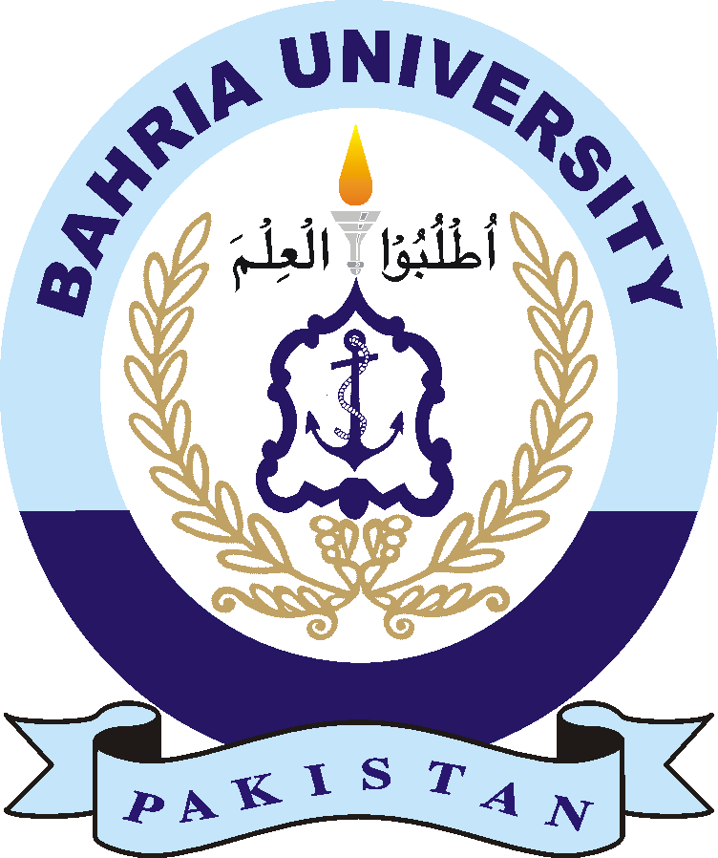

Question: Watch the mentioned TED Talks video and answer the asked questions.

1. What are the fours approaches to be happy?
2. Write down the summary of the mentioned video --- 100 words.

Answer: